

## PROJECT TITLE: Robot transformers

NAME: Essam Fiaz

ID: 3810484

Department of Computer Science and Engineering, Yanbu University College

CS376: Computer Graphics

Mr. Basim Iskandarani

Date

Scene Objects

**1- The character:**

I got the idea of character from watching movie (transformers) the movie is inspired me.

The robot has Head, 2 Ears, 2 Eyes, Forehead, Neck, 2 Arms, 2 Knee, Body, 2 Legs, 2 Hands.

So, the robot has 16 parts and I used blue color such as transformers movie and I used glutSolidCube() / glutSolidSphere() character

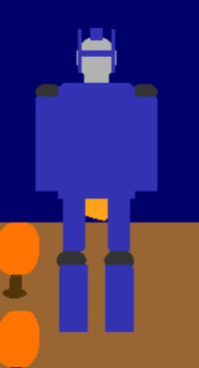

**2-Transformers:**

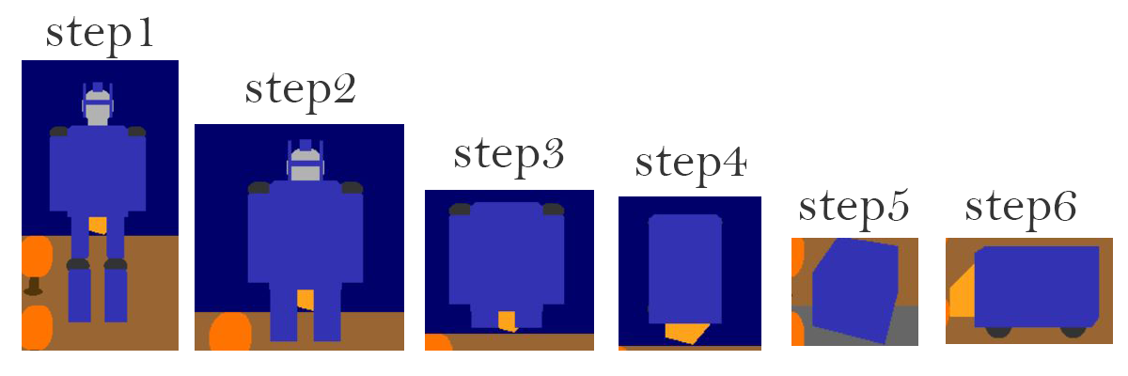

About the transform I designed a simple robot and I code to animate the robot. The idea is to collapse all the parts of robot and transform into vehicle as seen in the movie. When you will run the program, you will feel like watching the movie. Furthermore, I used trans() function to transform. Which is:

void trans()

{

if (yll < 130)

{

yll += 1;

ylu += 1;

yln += 1;

}

else if (yrh > 240)

{

yrh -= 1;

yre -= 1;

yrf -= 1;

ye -= 1;

yrnc -= 1;

}

else if (yll < 220)

{

yll += 1;

}

else if (rlh <= 560)

{

rlh += 1;

rrh -= 1;

rla += 0.9;

rra -= 0.9;

}

else if (rxa <= 90)

{

rxa += 1;

tz -= 2;

ty += 1.2;

}

else

{

flag = 1;

rxa = 0;

sx = 1.3;

sy = 0.5;

sz = 1;

}

}

Then, the last transform (step 6) transform to vehicle I used vehicle() function:

void vehicle()

{

glTranslatef(ftx, fty, ftz);

glScalef(fsx, fsy, fsz);

if (vflag == 1)

{

//Vehicle Hood

glColor3f(1, 0.639, 0.102);

glBegin(GL_QUADS);

glVertex3i(vtx, 35, 200);

glVertex3i(vtx + 60, 35, 200);

glVertex3i(vtx + 60, 90, 200);

glVertex3i(vtx, 58, 200);

glEnd();

//Front Wheel

glColor3f(0.2, 0.2, 0.2);

glTranslatef(540, wty, 200);

glScalef(1.7, 1, 0.2);

glutSolidSphere(12.5, 50, 50);

glScalef(1 / 1.7, 1, 1 / 0.2);

glTranslatef(-540, -wty, -200);

//Rear Wheel

glColor3f(0.2, 0.2, 0.2);

glTranslatef(655, wty, 200);

glScalef(1.7, 1, 0.2);

glutSolidSphere(12.5, 50, 50);

glScalef(1 / 1.7, 1, 1 / 0.2);

glTranslatef(-655, -wty, -200);

}

glColor3f(0.2, 0.2, 0.7);

glTranslatef(600, 60, 200);

glScalef(sx, sy, sz);

glRotatef(rya, 0, 1, 0);

glutSolidCube(120);

glRotatef(-rya, 0, 1, 0);

glScalef(1 / sx, 1 / sy, 1 / sz);

glTranslatef(-600, -60, -200);

glScalef(1 / fsx, 1 / fsy, 1 / fsz);

glTranslatef(-ftx, -fty, -ftz);

}

**3-The background:**

**I made trees, sky, cloud and floor for background just to make scene more realistic**

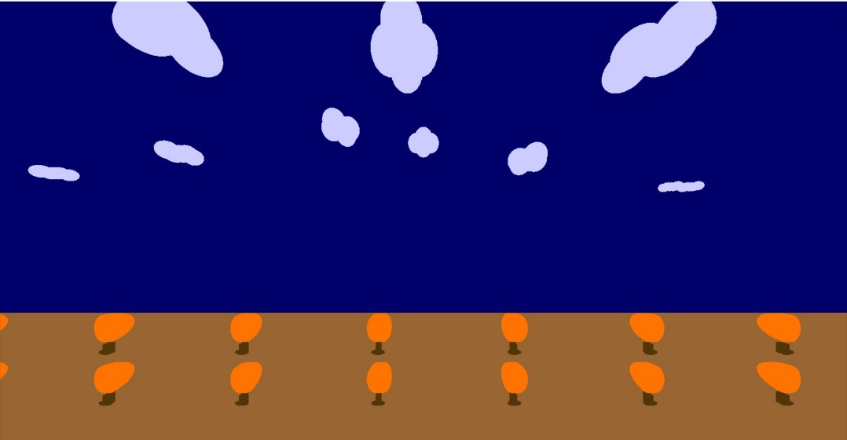

**The Floor: I used** GL_QUADS()

**The Sky: I used** glVertex3i()

**The Cloud and** Trees**: I used** glutSolidSphere()

**4-The sound effect:**

I used thrilling sound effect from the transformers movie by this code:

bool played = PlaySound("epic.wav", NULL, SND_ASYNC | SND_LOOP);

**Conclusion:**

After movie came many people think transformers(basically robot with Artificial Intelligence) may replace everything within the future. It's vital to understand about the transformers. The aim of this project is to point out the demonstration of working of transformers. This project demonstrates one among the simplest cartoon series of transformers, the project completely uses graphics and has been done using OpenGL. The code utilized in the program is extremely simple. we will easily understand the working of transformers by seeing the output of this project.